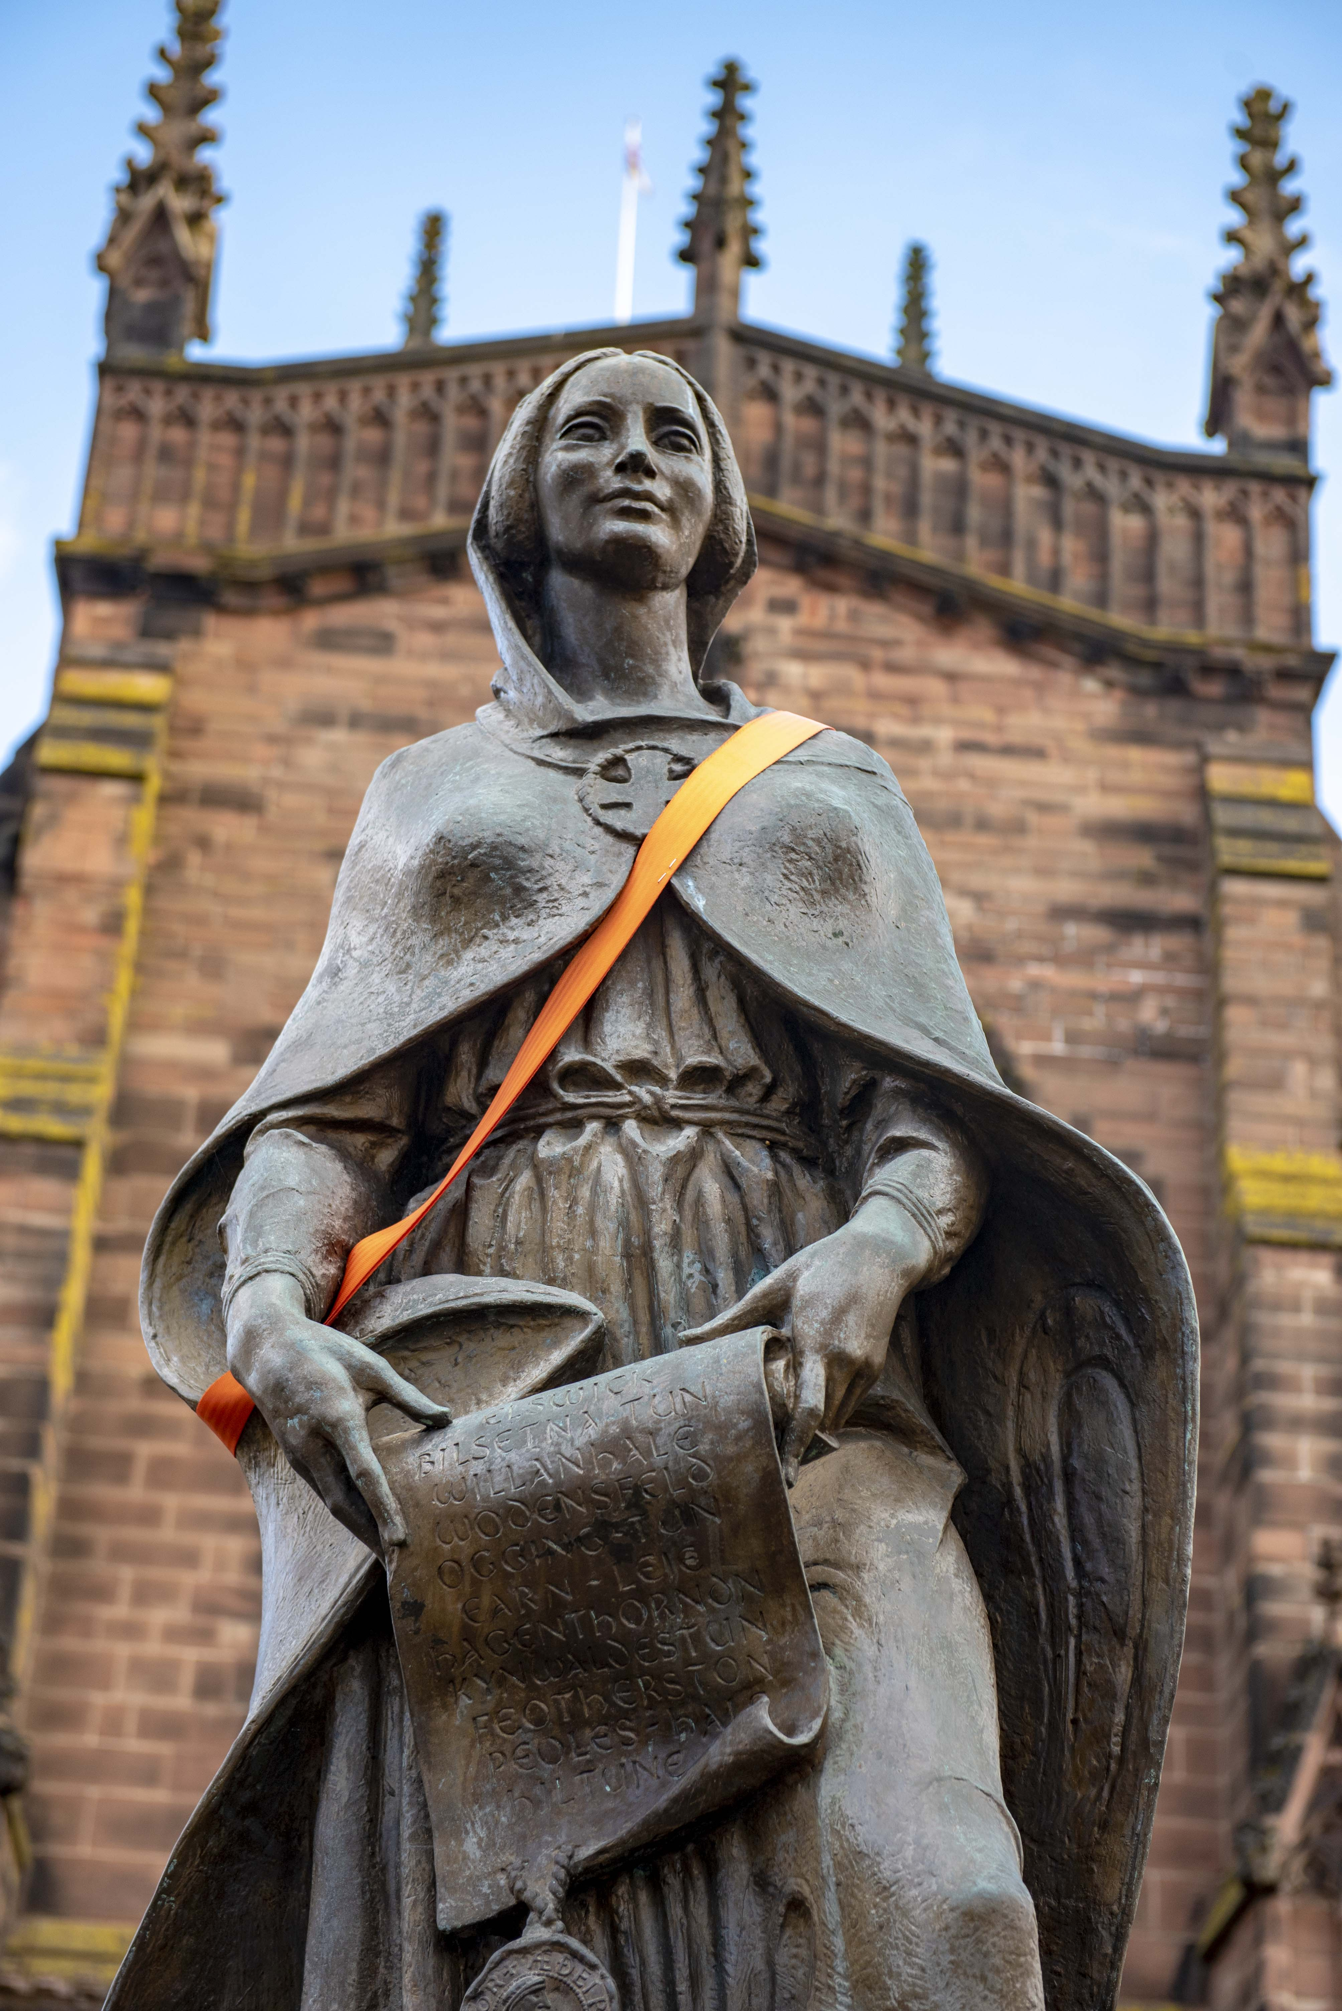

Violence Against Women and Girls
Tackling relationship-based abuse across all genders

Wolverhampton’s Multi-Agency Strategy 2019 -2022

December 2015
Foreword

To be completed

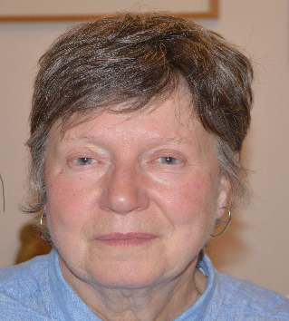

Cllr Hazel Malcolm
City of Wolverhampton Council
Penny Darlington
Chair, Wolverhampton Domestic Violence Forum

Mark Taylor,
Chair, Safer Wolverhampton Partnership

cONTENTS
To be inserted

Introduction
The Safer Wolverhampton Partnership (SWP) is the strategic lead for addressing Violence Against Women and Girls (VAWG) in Wolverhampton. The Partnership is committed to:
- Addressing the root cause of VAWG
- Challenging the perpetrators and holding them to account
- Alleviating the wide-ranging effects of all forms of VAWG on victims, survivors, their children and our communities.

Whilst the Violence Against Women and Girls Strategy name acknowledges the gendered nature of interpersonal violence, in that the majority of victims are female, it cannot be over-emphasised that the national and local strategies recognise that there are both female and male victims and perpetrators and therefore encompass work around women and girls, and also men and boys.

The Violence Against Women and Girls strategy covers six key themes: Domestic Violence (DV), Sexual Violence (SV), Female Genital Mutilation (FGM), Honour Based Violence (HBV), Forced Marriage (FM) and Stalking and Harassment.

These crimes are cross-cutting issues and there is a requirement to tackle them in partnership. Building on the significant progress made against previous strategies, partners continue to review their core operations, managing budgetary constraints against a backdrop of increasing demand. A greater collaborative effort is therefore needed in the commissioning and delivery of services to realise efficiencies, mitigate risk, address potential gaps in service, and shape new approaches. Data will also be reviewed regularly to identify any new forms of VAWG which require focus.

Wolverhamptons establishment of the first joint adult and children’s Multi-Agency Safeguarding Hub (MASH) in the West Midlands in 2016, strengthened the response to assessing and responding to the city’s safeguarding needs and integrating the domestic violence care pathway across universal services. Effective partnership working in many areas is improving the city’s response to VAWG; these include:

- Implementation of the VAWG Service Transformation Fund to address gaps in service and ensure sustainable improvements
- Development of an integrated response with partner boards through well informed policies, systems, and frontline practice.
- Safeguarding of survivors and children as paramount with risk-based responses.
- Behaviours challenged through effective perpetrator and offender management and a risk-based stepped model response to holding perpetrators and offenders to account
- Reduce repeat victimisation by delivering an effective criminal justice system holding offenders to account.
- Developing the communities’ role in addressing VAWG in all its forms.
- Maximising joint working opportunities by ensuring our local approach is aligned to regional and national efforts to address VAWG
- National, regional, sub-regional, and local policies and protocols, supporting delivery and aiding development of new approaches

National Context
Since the first VAWG Strategy in 2010, the Government has driven collaborative working towards its objectives for addressing VAWG through its Inter-Ministerial Group. The Government’s latest ending VAWG Strategy 2016-2020 retains the original framework of prevention, provision of services, partnership working and pursuing perpetrators.
It proposes a preventative model, service delivery transformation and a step change in social action to achieve sustainable long- term reductions in the inter-generational prevalence of these terrible crimes. The national Strategy continues to ratify women’s rights to live without the fear of violence and abuse outlined in the UN Convention on the Elimination of all Forms of Discrimination against Women.

In recent years there has been a significant shift in government policy to aid local delivery against VAWG. This has been supported by the introduction of significant new legislation requiring domestic homicide reviews to be undertaken with a view to learning lessons where a domestic violence death has occurred, the introduction of specific offences of stalking, forced marriage and revenge pornography, as well as the new domestic abuse offence to capture coercive or controlling behaviour in an intimate or family relationship. A range of new tools and powers have been introduced, which include DV, FM and FGM protection orders, a national DV disclosure scheme, and mandatory reporting of FGM by registered teaching, social care and health practitioners, as well as strengthened measures to manage sex offenders and those who pose a risk of sexual harm.

Regional Context

Across the West Midlands a multi-agency response to tackling VAWG has also gained momentum in recent years as efficiencies of cross-border working are realised. The seven Local Authority areas spanning the West Midlands Metropolitan area have a strong established history of collaborative working, covering not just the Community Safety Partnerships (CSPs), but also encompassing Local Authority leads, Safeguarding Boards and the work of the West Midlands Police & Crime Commissioner (PCC). The establishment of a West Midlands CSP provides further opportunity to prioritise these crimes and join up our regional approach.

The PCC has committed to improving services for victims of crime, including provision of a regional victims’ service and establishment of an independent Victims’ Commission to inform a wide range of provision across the West Midlands. The PCC’s Strategic Police & Crime Plan also highlights the commitment to protect people from harm, tackling hidden crimes including FGM, HBV and FM.

There are already positive examples of joint working that can be cited across the West Midlands. West Midlands DV minimum standards were approved by all 7 areas in 2014, setting out eleven key principles of working. Strategic learning from DHRs and opportunities for future cross-border working will continue to be identified during the life of our refreshed VAWG strategy.

VAWG Strategy 2016-2019 Successes

VAWG Strategy 2019-2022 Outcomes
The VAWG Strategy outcomes, objectives and principles remain in line with the national context. Our current situation and performance over the last three years have informed us of areas of focus to be considered as part of the new strategy.
Our Outcomes
Reduce the prevalence of VAWG
Increase the number and rate of reported VAWG offences brought to justice
Reduce serious harm resulting from VAWG, including homicide prevention
Build cross-agency skills and capability to provide effective VAWG advice and support services

Increase the number of perpetrators and offenders managed to reduce risk
Reduce the rate of repeat incidents for domestic violence
Increase early identification and intervention with victims of VAWG
Improve the criminal justice response to supporting victims of VAWG

These outcomes will be achieved whilst maintaining the following principles:
- Survivors/victims and perpetrators have access to services without discrimination due to disability, sexual orientation, race, religion/faith, culture, age or income group. Women-only services will be supported as will ensuring men’s access to other services.
- Services to survivors/victims and perpetrators will be designed and proportionate to the level of risk they face or pose.
- There is a commitment to providing quality services which draw on national and international best practice and standards.

Facing our Challenges in Partnership
Both the national and local strategy recognises the over-riding challenge is the need to move to a more preventative model of addressing VAWG; due to the cross-cutting nature of these issues, it is essential that this is done in partnership.

VAWG presents a number of challenges which require a partnership response:
- Gaps in provision of a recovery model approach to DV
- Impact on children - DV is a key predictor for Children and Young People in Care, Children in Need and Child Protection
- Management of increasingly complex cases
- Increasing demand and numbers of repeat cases
- Enhancing specialist knowledge into non-specialist front line services, and responding to new legislation
- Engagement of schools and education establishments
- Integration of behaviour change programmes
- Addressing housing needs and challenges
- Monitoring, auditing, and ensuring accountability
- There is a need to raise awareness and develop capacity and confidence of staff to respond
- Greater integration of VAWG responses is needed within core business of partners to inform commissioning & develop new approaches to growing demand

Whilst the crime types span all age groups, there are a number, where cultural practice within certain communities places children and young people at a significantly higher risk of harm.

- Young girls within recognised communities are particularly vulnerable to FGM
- The Forced Marriage Unit suggests young people aged 16-25 are most at risk of being forced into marriage
- Reported cases of HBV involved victims aged 16-17
- Local levels of risk within the city are currently being assessed.

The ‘Keeping Children Safe in Education’ updated guidance 2018 issued to schools, sets out clear expectations of schools and individual staff in identifying risks associated with FGM, alongside other safeguarding responsibilities. Practical support is still needed, however, to ensure schools are appropriately equipped with age-appropriate resources with staff up-skilled to fulfil these new requirements. The strategy will continue to work closely with schools on their responsibilities for promoting safe relationships amongst young people.

Despite improvements made in the partnership approach to respond to VAWG, an effective city-wide response must be developed with a shift in focus from crisis management to prevention, to stem the growing demand for high risk VAWG support services; maintaining the status quo is not an option. As a partnership, we need to move towards a position where we are preventing the cycle of abuse, identifying and supporting victims at a much earlier point to stem the escalation towards crisis and addressing abusive behaviours with perpetrators.
Domestic Violence
“any incident or pattern of incidents of controlling, coercive or threatening behaviour, violence, or abuse between those aged 16 or over who are or have been intimate partners or family members regardless of gender or sexuality. This can encompass but is not limited to psychological, physical, sexual, financial, & emotional abuse”

In the city in 2017-2018 there were 6251 domestic abuse incidents reported to the police (220 more incidents than the previous year)
47.3% of which were recordable offences
This increase in reporting is in part attributable to more accurate recording on Police systems, an increase in incidents reported in public places that have been witnessed and reported by third parties, and public confidence in reporting. DV is known to have the highest repeat rate of any crime and to escalate in frequency and severity over time, so it is important to monitor repeated reports of DV as an indicator of increasing risk, and the need to focus on managing that risk.

Despite this increase, the British Crime Survey recognises that:
“the under-reporting of crime to the Police is known to be
particularly acute for intimate violence offences”.

The increasing volume of domestic violence incident reports is impacting on existing services, as is the number of high-risk of serious harm cases referred to Multi Agency Risk Assessment Conference (MARAC) which has continued to increase year on year until 2017- 2018. Further specialist capacity is needed to manage all high-risk domestic violence cases within the city.

The learning from statutory Domestic Homicide Reviews (DHRs) has aided the move towards integrated partnership working.
Areas of Early Focus
- More effective management of low-medium risk cases through safety planning to avoid escalation of risk.
- Greater emphasis needed on reducing repeat victimisation.
- Improved provision for the management of complex cases.
- Embedding the stepped risk-model for managing offenders and perpetrators to shift the focus of responsibility and accountability from the victim to the offender.
- Direct preventative work in schools and other settings around positive relationships and protective behaviours
- Embedding learning from DHRs
- Joined up criminal and civil justice protection processes

 | 2016-2017 | 2017-2018
Reported Domestic Violence Incidents | 6031 | 6251
% Recordable offences | 42.4 | 47.3
MARAC cases | 652 | 651
% Repeat cases | 36 | 36
% Non-police referrals | 31 | 37

Female Genital Mutilation
Female genital mutilation refers to all procedures involving partial or total removal of the external female genitalia or other injury to the female genital organs for non-medical reasons. The Female Genital Mutilation Act (2003) makes it illegal to practice FGM in the UK, to take abroad British nationals or permanent UK residents for FGM, and to aid FGM being conducted abroad.

Wolverhampton is a proud well-integrated multi-cultural city. Alongside the advantages of our diversity, the city is home to residents who are from communities where forced marriage, so-called, honour- based violence, and female genital mutilation are prevalent.

Of significant concern is the fact that we have received few or no such reports of these crimes over the period of the previous strategy. As these crimes are often perpetrated by family members, there is an understandable reluctance for victims to report to police or seek support.

There is a need to address significant knowledge gaps and challenge accepted practice within our communities and amongst young people to dispel myths, and present the legal and medical facts, and consequences of these crimes to make it easier for victims to report with confidence. We also need to train our front-line staff in identifying risk of FGM and how to respond appropriately using the full range of powers available.

In 2016 Wolverhampton developed a problem profile outlining where FGM practicing communities were settled in our city and suggesting where targeted work could be undertaken to raise awareness of the illegalities and long-term harms associated with FGM.

Unicef data estimates the majority of FGM practice is carried out on girls under 14, with the majority cut before the age of 5, closely followed by those aged 5-9.
Areas of Early Focus
- Continue to raise awareness within targeted communities to emphasise the full legal, health and safeguarding implications of FGM.
- Seek feedback from survivors to shape future services to meet the needs of our diverse communities.
- Continue to raise awareness of FGM amongst frontline practitioners and increase understanding of mandatory reporting requirements.
- Strengthen engagement with schools, especially leading up to the summer holiday ‘cutting season’
- Work with community and faith organisations to raise awareness and challenge acceptance
- Improve systematic recording of FGM across partners
- Update the profile of communities where FGM is prevalent within their countries of origin

 | 2016-2017 | 2017-2018
Number of FGM incidents reported to the police | 17 | 27
% which are recordable offences | 1 | 0

Forced Marriage
A forced marriage is a marriage in which one or both spouses do not (or in the case of some adults with learning or physical disabilities, cannot) consent to the marriage and duress is involved. Duress can include physical, psychological, financial, sexual and emotional pressure. Coercion is likely to have been used with one or both spouses; by family members, friends and the wider community.

The practice of forced marriage is not confined to one culture or religious group and can happen regardless of ethnicity, culture, religion, disability, age, gender and sexuality. It is significantly different from an arranged marriage which is a respected tradition in many cultures where both parties give their consent.

FM is now a specific offence under s121 of the Anti-Social Behaviour, Crime and Policing Act 2014. The Forced Marriage (Civil Protection) Act 2007 inserted provisions for the courts to make Forced Marriage Protection Orders to prevent forced marriages from occurring and to protect those who have already been forced into marriage.

The Mental Capacity Act 2005 states that all adults, (unless proved otherwise), have the capacity to make decisions. There is no legal basis on which someone can agree to marriage, civil partnerships or sexual relations on behalf of someone who lacks the capacity to make these decisions independently.

During 2017-2018 there were four Forced Marriage
incidents recorded by the police

Areas of Early Focus
- Develop profile to better identify prevalence
- Raise awareness of FM amongst frontline practitioners.
- Raise awareness across communities of the illegality of FM.
- Support schools to deliver key messages regards FM within the curriculum.

 | 2016-2017 | 2017-2018
Forced marriage incidents reported to the police | 5 | 4
% of recordable offences | 80 | 25
Honour Based Violence
So-called Honour based violence is defined as ‘a crime or incident, which has or may have been committed to protect or defend the honour of the family and/or community’.

There is no specific offence of so-called, "honour based crime". It is an umbrella term to encompass various offences covered by existing legislation. HBV can be described as a collection of practices, which are used to control behaviour within families or other social groups to protect perceived cultural and religious beliefs and/or honour.

Such violence can occur when perpetrators perceive that a relative has shamed the family and/or community by breaking their honour code. Punishment can be imposed because of a belief, actual or perceived, that a person has not been properly ‘controlled’ and is failing to conform to family or community expectations. Linked offences can include threats, theft (e.g. passport), assault – physical or sexual, kidnap, abduction or imprisonment or rape.

During 2017-2018 there were 24 Honour-based Abuse
incidents recorded by the police
Areas of Early Focus
- Refresh of the Wolverhampton FM and HBV protocol for frontline practitioners
- Raise awareness of HBV amongst frontline practitioners
- Raise awareness across communities of the illegality of HBV-related crimes and engage communities to challenge cultural norms
- Support schools to deliver key messages regards HBV within the curriculum.

 | 2016-2017 | 2017-2018
Honour based violence incidents recorded by the police | 24 | 24
% that are recordable offences | 62.5 | 67

Sexual Violence
Sexual violence is defined as ‘any behaviour perceived to be of a sexual nature, which is unwanted and takes place without consent or understanding’.

The Sexual Offences Act 2003 protects individuals from abuse and exploitation, and is designed to be fair and non-discriminatory.

The quality of services for victims of sexual assaults has been improved through provision of a West Midlands Sexual Assault Referral Centre (SARC), with a local Independent Sexual Violence Adviser (ISVA) services providing specialist advice and support.
Areas of Early Focus
- Promotion of reporting and care pathways including to/from the SARC.
- Promoting with frontline staff, the links to CSE.
- Strengthen care pathways for specialist adult and child provision

 | 2016-2017 | 2017-2018
Serious sexual offences reported to the police | 535 | 615

Stalking and Harassment
Stalking is ‘a pattern of fixated and obsessive behaviour which is repeated, persistent, intrusive and causes fear of violence or engenders alarm or distress in the victim.’

The Protection of Freedoms Act (2012) identifies stalking as a criminal offence, allowing prosecution of perpetrators indulging in behaviour that causes the victim harassment, alarm or distress. This can include behaviour which consists of stalking or harassing victims online, by post, by direct personal contact or a combination of these channels. Stalking and harassment is thought to effect 1 in 5 women and 1 in 10 men and victims tend not to report it until around the 100th incident.
Areas of Early Focus
- Raise awareness of the law and legal implications relating to stalking and harassment.
- Raise awareness of stalking and harassment amongst frontline practitioners.
- Promotion of reporting and available care pathways.

System Improvements
In addition to bespoke delivery around each of the VAWG strands, there will be more generic activity spanning all strands:
- Deploy all powers available through the partnership to protect victims and manage offenders/perpetrators.
- Embed risk based decisions and responses across frontline practice.
- Improve criminal and civil justice responses.
- Strengthen systematic data monitoring and analysis.
- Embed learning from domestic homicide reviews & serious case reviews, and evidence changed practice.
- Strengthen governance and reporting arrangements.
- Embed clear referral pathways which are understood by communities and organisations, including to the SARC.
- Continue a sustainable programme of staff training.
- Embed robust, cross-agency policies and procedures.
- Support schools to cascade key messaging to pupils.

There is a range of criminal justice and civil remedies that protect victims and children witnessing VAWG, a detailed list can be found in the appendices.

Delivery

Underpinning the strategy is an action plan which will set out the main actions to move us closer to achieving our strategy objectives and outcomes. The strategy and action plan require a commitment from partners to review their delivery contributions against objectives. Alongside this will be active approaches to seek funding from external sources available through voluntary sector bids to foundation trusts and other grant providing sources.

The key themes of the action plan are Prevention, Provision, Protection & Justice, and Performance.

The action plan will be monitored through WDVF’s Executive Board, with governance provided by SWP Board. The action plan will be reviewed annually and aligned to a risk register, highlighting areas of underperformance with mitigating actions agreed.

The VAWG strategy and action plan do not sit in isolation; VAWG cuts across a number of other national, regional, and local strategies (see appendix for list of related strategies). There are well established relationships with other strategic Boards in relation to some of the shared areas of responsibility for these cross-cutting issues. There are also clear links and overlaps between VAWG and other high-profile issues including child sexual exploitation (CSE), gang and youth violence, and modern slavery, and reoffending generally. This strategy will ensure that work is cross-referenced across these subject areas.

Model of Delivery
The UK national model of best practice in dealing effectively with violence against women and girls is that of a coordinated community response model. This model requires a broad community ownership, so it becomes everybody’s business and there is a collective response advocating that VAWG is not acceptable, will not be tolerated, and that it will be dealt with appropriately by holding perpetrators to account and safeguarding victims/survivors and their children.

In order to achieve a coordinated community response to VAWG in Wolverhampton underpinning our strategy outcomes, the action plan focuses on achieving the following fundamental building blocks:

Wolverhampton’s Over-Arching DV Protocol was refreshed in 2018 and endorsed by The Safer Wolverhampton Partnership Board, and the Safeguarding Children and Adult Boards. Member organisations are working towards complying with the 16 organisational requirements included in the protocol (Appendix 2). This protocol has been incorporated into a West Midlands Domestic Violence Standards document, the principles of which are being integrated into partners’ core business.

Equality & Diversity
It is fundamentally important to emphasise that the national strategy name is an acknowledgement of the gendered nature of domestic and sexual violence and abuse, in that the majority of victims are female. However, the national and local strategies recognise that there are both female and male victims and perpetrators and therefore encompass work around women and girls, and also men and boys.
Those who may have barriers to seeking support include:
- Male victims
- Our Black, Asian, Minority, Ethnic, and Refugee communities
- Survivors with disabilities
- Older victims
- Victims under 18 years
- Lesbian, Gay, Bisexual, Transsexual, and Transgender communities
- Those with no recourse to public funding
- Those with complex needs including mental ill-health and substance misuse issues.
The strategy also acknowledges and aims to address the additional barriers to seeking help for particular groups. One of the eleven West Midlands Domestic Violence standards specifically covers issues of equality and diversity. There are specific cultural aspects of DV, some of which have arisen in DHRs, and recommendations in respect of these are being progressed within the VAWG strategy implementation. A full equalities analysis informs our approach.

Acknowledgements
This draft strategy has been put together by member organisations of the Safer Wolverhampton Partnership, Wolverhampton Domestic Violence Forum and Wolverhampton Safeguarding Adults and Children Boards.

Appendix 1
Over-Arching Domestic Violence Protocol 2018 - organisational requirements:
- Have in place a domestic violence policy for service users
- Have in place a workplace domestic violence policy
- Include a routine question about domestic violence on referral forms/assessments
- Provide spaces for individuals to make safe disclosures
- Hold organisational knowledge about how to avoid unsafe responses
- Ensure that responses are culture and diversity aware
- Train staff in domestic violence to an appropriate level depending on their role, including having a nominated VAWG Champion(s)
- Undertake a DASH risk assessment, or have in place an agreed referral pathway for a DASH risk assessment to be undertaken when domestic violence is disclosed
- Ensure the case is referred to MARAC where the risk assessment identifies the individual as high risk of serious harm or homicide
- Maintain up to date contact details of appropriate local help and information and leaflets to signpost victims to specialist support agencies
- Ensure learning from domestic homicide reviews is embedded
- Where appropriate, ensure that perpetrator programmes incorporate RESPECT standards
- Share domestic violence datasets through partnership arrangements (when requested)
- Ensure these requirements and The West Midlands DV Standards are incorporated into designing, commissioning, and contracting services
- Seek assurance that these requirements and The West Midlands DV Standards are embedded via internal audits
- Provide an annual statement of compliance with these requirements to WDVF Exec Board on request.

Appendix 2

Glossary of terms:

CSE – Child Sexual Exploitation | ISVA – Independent Sexual Violence Advisor
CSP – Community Safety Partnership | MARAC – Multi-agency risk assessment conference
DHR – Domestic Homicide Review | MASH – Multi-Agency Safeguarding Hub
DASHH– Domestic abuse, stalking harassment and honour-based violence risk assessment | PCC – Police and Crime Commissioner
DV – Domestic Violence | SARC – Sexual Assault Referral Centre
FGM – Female Genital Mutilation | SV – Sexual Violence
FM – Forced Marriage | SWP – Safer Wolverhampton Partnership
HBV – Honour-Based Violence | VAWG – Violence Against Women and Girls
IDVA – Independent Domestic Violence Advisor | WDVF – Wolverhampton Domestic Violence Forum

